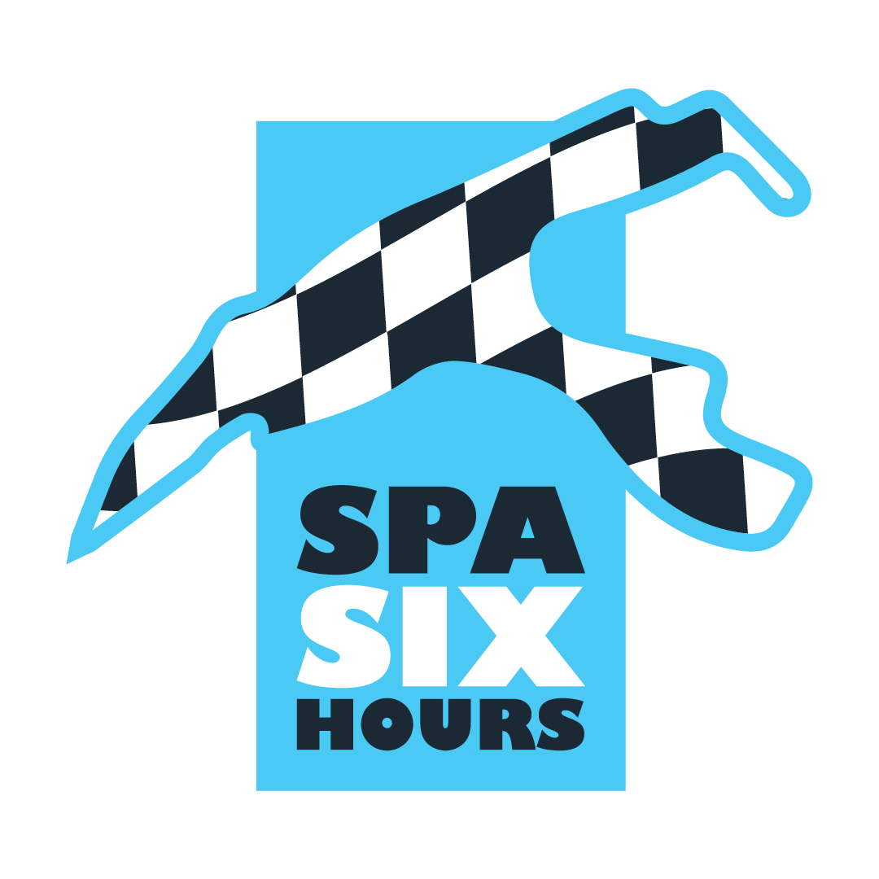
For the pleasure of the senses...

For three days, Spa Six Hours transformed the Circuit de Spa-Francorchamps into a formidable time machine. It was enough to delight a huge audience who took full advantage of the spectacle of single-seaters, prototypes, GTs, sports cars and touring cars, not without celebrating some of the great names in international motor sport. Here's a review of the highlights of the Roadbook event...

Classic Sports Car Club
The cars in the Swinging Sixties and Classic-K categories had the honour of kicking off the racing programme on Thursday evening... in weather that would not let a racing car out of its box! In these conditions, and with the Griffith and Tuscan TVRs expected, it was Sam Polley's modest Mini Marcos that emerged, despite a penalty, to win ahead of Dean Hasley's Datsun 240 Z and the Ford Mustang of Classic-K winner Michael Withaker Jr.
Early on Friday evening, Race 2 was contested on a darkened Spa-Francorchamps circuit. And it was payback time for Connor Kay, whose TVR Tuscan quickly climbed to the top of the standings to take an authoritative victory ahead of Nicholas King's Aston Martin DB4 and the Mini Marcos of the previous day's winner, Sam Polley. Michael Withaker Jr led a hat-trick of Ford Mustangs in Classic-K, ahead of Russel-Chilleystone and Dunham-Owen.
Masters Endurance Legends & Masters GT Trophy
Race 1 of the Masters Endurance Legends & Masters GT Trophy got underway on Friday morning, on a track that was still tricky. Japan's Yutaka Toriba and Yuya Hiraki started from pole position in their BR01, but it was an ex-P1, Stuart Wiltshire's Peugeot 90X, that took the lead to win ahead of the Pescarolo LMP1 of Christophe and Werner D'Ansembourg, second on home soil, and the best BR01, that of Briton Shaun Lynn. On the GT Trophy front, it was a one-two for the Ferrari 488 Challenge, with Darren Howell and Sean Doyle ahead of Jac and Ties Meeuwissen.
Early in the evening, torrential downpours at Spa-Francorchamps prompted Race Direction to cancel Race 2 for safety reasons.
F3 Classic Interseries
The track was drying out for the first F3 Classic Series race late on Friday morning. Despite the notable presence of Tristan Gommendy, at the wheel of an Argo JM10, it was the March 783s that took Race 1 by storm, with Andy Smith narrowly retaining the lead over Davide Leone. Gommendy, winner of his class, completed the first top 3 of the weekend, ahead of the Ralt RT3 of Manfredo Rossi di Montelera.
Andy Smith was at it again in Race 2, as the rain made its appearance on Friday afternoon, with a second win with his March 783, while Tristan Gommendy, once again winner of his class, this time took second place overall, ahead of Davide Leone and Manfredo Rossi di Montelera.
Historic Grand Prix Cars Association – Pré-66 Grand Prix Cars
The pre-66 F1 Race 1 was a tug-of-war at midday on Friday, with Maxime Castelein (Lotus 18) battling for victory for a long time at the wheel of the ex-Innes Ireland single-seater. Unfortunately, a technical problem forced the Belgian driver to retire, allowing Germany's Rudiger Friedrichs to win in his ex-Jack Brabham Cooper T53 ahead of Tim Child's Brabham BT3/4 and Charlie Martin's Cooper T53. As for the front-engined Grand Prix cars, victory went to Mark Shaw's original Scarab Offenhauser, which got the better of John Spiers' Maserati 250F and Geraint Owen's Kurtiss 500 C.
Race 2, contested on a track that was treacherous, produced a huge surprise on Saturday, from the moment Rudiger Friedrichs was threatened right to the end by the... Maserati 250F of John Spiers! The car driven by Jean Behra in 1955 finished second overall but won the front-engined category ahead of Rod Jolley's spectacular Lister Jaguar ‘Monzanapolis’ and Geraint Owen's Kurtis 500C. In the rear-engined single-seaters, Philipp Buhofer (BRM P261) and Tim Child (Brabham BT3/4) completed the standings.
Masters Gentlemen Drivers & Masters Pre-66 Touring Cars
Run over 90 minutes, the Masters Gentlemen Drivers & Masters Pre'66 Touring Cars race was marked by a fine domination by the Shelby Cobra Daytona Coupé of Briton Julian Thomas... even if his fine lead melted like snow in the sun as soon as the race was neutralised following an incident at Eau Rouge. At the Restart, after the mandatory pit-stop, Thomas again took off to win ahead of the Shelby Cobra of Dutchmen Abraham Bontrup and Olivier Hart, and the Jaguar E-Type of Belgian Vincent Gaye, very well accompanied by Briton Phil Keen. In contention for the podium, the Shelby Cobra of Christophe Van Riet and Fred Bouvy fell back in the standings after a Drive Through for Track Limits. In the Touring category, it was the Ford Mustang of Briton Michael Whitaker Jr that won ahead of the Falcon of his compatriot Robin Ward.
F2 Classic Interseries
March clearly dominated Race 1 on the Formula 2 front, with Matthew Watts imposing his ex-Eddie Cheever single-seater at the end of the 11 laps, ahead of Germany's Wolfgang Kaufmann and Britain's Alex Kapadia. In addition to the single-seaters powered by 2-litre engines, the 1600cc category saw Martin Wood impose his March on the Formula Atlantic side, while Julian Stokes distinguished himself in F2-1600cc with his Brabham BT30.
Race 2 was about to get underway when Matthew Watts was forced to return to the pitlane with technical problems. Wolfgang Kaufmann took full advantage of the situation, racing away to take victory despite a Safety Car period at the end of the race. Mark Charteris held off the best Formula Atlantic driver, Thomas Smith (March), to take^{3rd} place, while in the F2-1600cc class, Julian Stokes took his second Brabham victory, narrowly edging out the Crosslé of Germany's Bastian Bender.
Masters Racing Legends F1 Cars 1966-1985
A sumptuous field of 26 single-seaters on the historic F1 front, with the more than notable presence of Thierry Boutsen, three-time Grand Prix winner, at the wheel of a superb ex-Pryce Shadow DN5, and comedian and actor Stéphane De Groodt in an ex-Wisell March 741. Unfortunately, the two Belgians were technically unlucky, which sent them back to the pitlane. At the front of the field, the battle raged between Matthew Wrigley (Tyrrell 011), Olivier Hart (Arrows A3), as well as Christophe D'Ansembourg (Williams FW07C) and his son Werner (Brabham BT49). The pressure was on from the younger generation, and although Wrigley won, it was by the narrowest of margins ahead of Werner D'Ansembourg and Olivier Hart! Nick Padmore imposed his Lotus 77 in the class of single-seaters without ground effect.
It was pouring down at the start of Race 2 on the F1 front of the ‘70s and ’80s. Between neutralisations, Nick Padmore managed to get the ex-Andretti/Nilsson Lotus 77, with no ground effect, into the lead, before the younger cars took the lead. It was young Olivier Hart who emerged to win what was only his second race in F1 Historic, giving the ex-Patrese Arrows A3 a new lease of life! Matthew Wrigley and Matteo Ferrer-Aza (Ligier JS11/15) completed the podium, while Padmore won his class ahead of Thierry Boutsen, the public darling in the Shadow DN5, who made a thunderous comeback from the back of the grid to finish 5th overall. Less success for Stéphane De Groodt, betrayed by his mechanics, and Werner D'Ansembourg, involved in contact at the Brussels hairpin.
Masters Sports Car Legends
The rain was in full force as the powerful engines of the Masters Sports Car Legends took to the track for a 60-minute race. It wasn't long before the Lola T70s of David Hart and Chris Ward were in the lead, before Ward overtook the Dutchman... only to come back into the pitlane with his engine out! In the end, the battle for victory was between the Lola T70 of Hart father and son and the McLaren M1B which John Spiers handed over to Nigel Greensall for the second half of the race. The lead changed hands several times, and it was Olivier Hart who had the last word, after a mistake by Nigel Greensall on the final lap. Once again, it was a battle of the generations! It was the Lola T296 of Gonçalo Gomez and James Claridge that completed the final top 3, keeping ahead of the very efficient Elva Mk8 of Dion Kremer and Ben Mitchell.
RAC Woodcote Trophy & Stirling Moss Trophy
It rained again on Saturday morning for the start of the Woodcote Trophy and Stirling Moss Trophy races, with New Zealander Roger Wills leading the pack in his Lotus XV. He never relinquished this advantage for long, before being caught out in the closing laps by Austrian Lukas Halusa in the Jaguar D-Type 2nd of the 1954 Le Mans 24 Hours! Halusa came within 1'’8 of Wills to win the Woodcote Trophy, while the winning Lotus was the winner of the Stirling Moss Trophy. Ben Mitchell and Dion Kremer finished superbly in the Lotus 17, narrowly beating the Jaguar C-Type of Germany's Rudiger Friedrichs.
Historic Formula Junior
The starting grid for the Historic Formula Junior event was impressive, with these 1100cc single-seaters bridging the gap between the ‘50s and ’60s. And while the number of manufacturers, including countless craftsmen, was astonishing, it was the Lotus cars that dominated Race 1 on Friday, Clive Richards imposing his 22 ahead of the similar cars of Manfredo Rossi di Montelera and Lukas Halusa. At the wheel of a Lotus 27, Richard Wilson maintained his lead over Stuart Roach's Alexis Mk4 for 4th place.
On Saturday morning, on a wet track, Rossi di Montelera got his revenge, taking advantage of some problems suffered by Clive Richards. Stuart Roach and Lukas Halusa completed the second podium of the weekend, ahead of the other Lotus of Richard Wilson and Nicolas Carlton-Smith.
Pre-War Sports Cars
The oldest cars in the meeting, sports cars from the ‘20s and ’30s, took on the halberds early on Saturday afternoon. And it was Rudiger Friedrichs' Alvis Firefly Special that emerged at the end of the 11-lap race, with an advantage of just three seconds over the Frazer Nash TT of Briton Robert Beebee. Christopher Mann's superb Alfa Romeo 8C Monza completed the podium, while the spectacular three-wheeled Morgan Super Aero of the Darbyshire/Wood duo rounded off the final top 5!
Spa Six Hours Endurance
The 2024 edition of the Spa Six Hours came to a close with a six-hour race in the form of a fireworks display! With around twenty Ford GT40s on the starting grid, track conditions that were as changeable as you could wish for, a crazy soundtrack and some beautiful battles, the public, which was very large on Saturday, was won over. In the end, the legendary cars with the blue oval put on a great show, with the #8 of David Hart, Olivier Hart and Nicky Pastorelli on course for victory... before running aground in the Pif-Paf gravel trap with less than half an hour to go! It was a godsend for the #41 of Dario and Marino Franchitti, accompanied by André Lotterer, who didn't give up, eventually winning the overall classification and joining the prestigious list of winners of the event!

As for the podium, it was completed by the best Lotus Elan 26R, that of Gordon Shedden, Ben Barker and Rory Butcher, which beat... 8 other GT40s: Pearson-Brundle-Harris, Sanchez-Salewsky-Funke, Bryant-Twyman-Keen, Wakeman-Smith-Grant Peterson, Macedo Silva-Monroy, Wood-Nuthall-Lyons, Meins-Lillingston Prince-Huff, and Lynn-Lynn-Haddon. A great line-up...

The GT40s driven by the other Belgians were less successful, with Nico Verdonck dominating the first part of the race at the wheel of the #30, before running into engine power problems, while Eric van der Poele, accompanying Jim Farley in the #98, ended up losing fourth gear on his car.

The little Ginetta G4R of Pedersen-Kjaergaard-Weiss also got off to a storming start, taking advantage of lower fuel consumption to threaten the Ford GT40s a third of the way through the race, before unfortunately being forced to retire.

Free of rights pictures : Michaël Demey
Results: http://roadbook.alkamelsystems.com/

www.spasixhours.com

